**PRACTICAL: 8**

**AIM:** Create an application with the help of fragment.

**THEORY:**

* Fragment: A Fragment is a piece of an activity which enable more modular activity design. It will not be wrong if we say, a fragment is a kind of sub-activity.
* You create fragments by extending Fragment class and You can insert a fragment into your activity layout by declaring the fragment in the activity's layout file, as a <fragment> element.

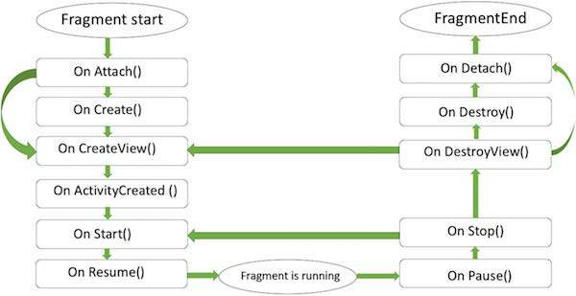

* **onAttach()**The fragment instance is associated with an activity instance.The fragment and the activity is not fully initialized. Typically you get in this method a reference to the activity which uses the fragment for further initialization work.
* **onCreate()** The system calls this method when creating the fragment. You should initialize essential components of the fragment that you want to retain when the fragment is paused or stopped, then resumed.
* **onCreateView()** The system calls this callback when it's time for the fragment to draw its user interface for the first time. To draw a UI for your fragment, you must return a **View** component from this method that is the root of your fragment's layout. You can return null if the fragment does not provide a UI.
* **onActivityCreated()**The onActivityCreated() is called after the onCreateView() method when the host activity is created. Activity and fragment instance have been created as well as the view hierarchy of the activity. At this point, view can be accessed with the findViewById() method. example. In this method you can instantiate objects which require a Context object
* **onStart()**The onStart() method is called once the fragment gets visible.
* **onResume()**Fragment becomes active.
* **onPause()** The system calls this method as the first indication that the user is leaving the fragment. This is usually where you should commit any changes that should be persisted beyond the current user session.
* **onStop()**Fragment going to be stopped by calling onStop()
* **onDestroyView()**Fragment view will destroy after call this method
* **onDestroy()**onDestroy() called to do final clean up of the fragment's state but Not guaranteed to be called by the Android platform.

**CODE:**

|  |
| --- |
| **MainActivity.java**  package com.example.wcmc_pract_8_17it022;  import androidx.appcompat.app.AppCompatActivity;  import androidx.fragment.app.Fragment;  import androidx.fragment.app.FragmentManager;  import androidx.fragment.app.FragmentTransaction;  import android.os.Bundle;  import android.view.View;  import android.widget.Button;  import android.widget.CalendarView;  import android.widget.FrameLayout;  public class MainActivity extends AppCompatActivity {  private Button b1,b2,b3,b4;  private FrameLayout myFrame;  @Override  protected void onCreate(Bundle savedInstanceState) {  super.onCreate(savedInstanceState);  setContentView(R.layout.activity_main);  Button b1 = findViewById(R.id.button);  Button b2 = findViewById(R.id.button2);  Button b3 = findViewById(R.id.button3);  Button b4 = findViewById(R.id.button4);  myFrame = findViewById(R.id.frame1);  b1.setOnClickListener(new View.OnClickListener(){  @Override  public void onClick(View v) {  myFrame.removeAllViews();  FragmentManager fragmentManager = getSupportFragmentManager();  FragmentTransaction fragmentTransaction =fragmentManager.beginTransaction();  fragment1 frag1 = new fragment1 ();  fragmentTransaction.add(R.id.frame1,frag1);  fragmentTransaction.commit();  }  });  b2.setOnClickListener(new View.OnClickListener() {  @Override  public void onClick(View v) {  myFrame.removeAllViews();  FragmentManager fragmentManager = getSupportFragmentManager();  FragmentTransaction fragmentTransaction = fragmentManager.beginTransaction();  fragment2 frag2 = new fragment2();  fragmentTransaction.add(R.id.frame1,frag2);  fragmentTransaction.commit();  }  });  b3.setOnClickListener(new View.OnClickListener() {  @Override  public void onClick(View v) {  myFrame.removeAllViews();  FragmentManager fragmentManager = getSupportFragmentManager();  FragmentTransaction fragmentTransaction = fragmentManager.beginTransaction();  fragment3 frag3 = new fragment3();  fragmentTransaction.add(R.id.frame1,frag3);  fragmentTransaction.commit();  }  });  b4.setOnClickListener(new View.OnClickListener() {  @Override  public void onClick(View v) {  myFrame.removeAllViews();  FragmentManager fragmentManager = getSupportFragmentManager();  FragmentTransaction fragmentTransaction = fragmentManager.beginTransaction();  fragment4 frag4 = new fragment4();  fragmentTransaction.add(R.id.frame1,frag4);  fragmentTransaction.commit();  }  });  }  }  **activity_main.xml**  <?xml version="1.0" encoding="utf-8"?>  <RelativeLayout  xmlns:android="http://schemas.android.com/apk/res/android"  xmlns:app="http://schemas.android.com/apk/res-auto"  xmlns:tools="http://schemas.android.com/tools"  android:layout_width="match_parent"  android:layout_height="match_parent"  tools:context=".MainActivity"  android:background="@drawable/gradient1">  <Button  android:id="@+id/button"  android:layout_width="82dp"  android:layout_height="36dp"  android:layout_marginTop="10dp"  android:layout_marginLeft="5dp"  android:background="@drawable/b1"  android:text="PR : 1"  android:textColor="#fff"  android:textSize="18sp"  app:layout_constraintBottom_toBottomOf="parent"  app:layout_constraintCircleRadius="10dp"  app:layout_constraintEnd_toEndOf="parent"  app:layout_constraintHorizontal_bias="0.047"  app:layout_constraintStart_toStartOf="parent"  app:layout_constraintTop_toTopOf="parent"  app:layout_constraintVertical_bias="0.023" />  <Button  android:id="@+id/button2"  android:layout_width="86dp"  android:layout_height="37dp"  android:layout_marginTop="10dp"  android:layout_marginLeft="95dp"  android:background="@drawable/b2"  android:text="PR : 2"  android:textColor="#fff"  android:textSize="18sp"  app:layout_constraintBottom_toBottomOf="parent"  app:layout_constraintEnd_toEndOf="parent"  app:layout_constraintHorizontal_bias="0.318"  app:layout_constraintStart_toStartOf="parent"  app:layout_constraintTop_toTopOf="parent"  app:layout_constraintVertical_bias="0.023" />  <Button  android:id="@+id/button3"  android:layout_width="84dp"  android:layout_height="37dp"  android:layout_marginTop="10dp"  android:layout_marginLeft="188dp"  android:background="@drawable/b3"  android:text="PR : 3"  android:textColor="#fff"  android:textSize="18sp"  app:layout_constraintBottom_toBottomOf="parent"  app:layout_constraintEnd_toEndOf="parent"  app:layout_constraintHorizontal_bias="0.633"  app:layout_constraintStart_toStartOf="parent"  app:layout_constraintTop_toTopOf="parent"  app:layout_constraintVertical_bias="0.021" />  <Button  android:id="@+id/button4"  android:layout_width="76dp"  android:layout_height="37dp"  android:layout_marginLeft="278dp"  android:layout_marginTop="10dp"  android:background="@drawable/b4"  android:text="PR : 4"  android:textColor="#fff"  android:textSize="18sp"  app:layout_constraintBottom_toBottomOf="parent"  app:layout_constraintEnd_toEndOf="parent"  app:layout_constraintHorizontal_bias="0.951"  app:layout_constraintStart_toStartOf="parent"  app:layout_constraintTop_toTopOf="parent"  app:layout_constraintVertical_bias="0.025" />  <FrameLayout  android:layout_width="match_parent"  android:layout_height="match_parent"  android:id="@+id/frame1"  android:layout_below="@+id/button"  android:layout_marginTop="10dp">  </FrameLayout>  </RelativeLayout>  **Fragment1.xml**  <?xml version="1.0" encoding="utf-8"?>  <LinearLayout xmlns:android="http://schemas.android.com/apk/res/android"  xmlns:app="http://schemas.android.com/apk/res-auto"  android:orientation="vertical" android:layout_width="match_parent"  android:layout_height="match_parent"  >  <ImageView  android:layout_width="fill_parent"  android:layout_height="wrap_content"  android:src="@drawable/capture1"  android:layout_marginTop="50dp"  />  </LinearLayout>  **Fragment2.xml**  <?xml version="1.0" encoding="utf-8"?>  <LinearLayout xmlns:android="http://schemas.android.com/apk/res/android"  android:orientation="vertical" android:layout_width="match_parent"  android:layout_height="match_parent">  <ImageView  android:layout_width="fill_parent"  android:layout_height="wrap_content"  android:src="@drawable/capture2"  android:layout_marginTop="50dp"  />  </LinearLayout>  **Fragment3.xml**  <?xml version="1.0" encoding="utf-8"?>  <LinearLayout xmlns:android="http://schemas.android.com/apk/res/android"  android:orientation="vertical" android:layout_width="match_parent"  android:layout_height="match_parent">  <ImageView  android:layout_width="fill_parent"  android:layout_height="wrap_content"  android:src="@drawable/capture3"  android:layout_marginTop="50dp"  />  </LinearLayout>  **Fragment4.xml**  ?xml version="1.0" encoding="utf-8"?>  <LinearLayout xmlns:android="http://schemas.android.com/apk/res/android"  android:orientation="vertical" android:layout_width="match_parent"  android:layout_height="match_parent">  <ImageView  android:layout_width="fill_parent"  android:layout_height="wrap_content"  android:src="@drawable/capture4"  android:layout_marginTop="50dp"  />  </LinearLayout>  **AndroidManifest.xml**  <?xml version="1.0" encoding="utf-8"?>  <manifest xmlns:android="http://schemas.android.com/apk/res/android"  package="com.example.wcmc_pract_8_17it022">  <application  android:allowBackup="true"  android:icon="@mipmap/ic_launcher"  android:label="PR_8_fragment"  android:roundIcon="@mipmap/ic_launcher_round"  android:supportsRtl="true"  android:theme="@style/AppTheme">  <activity android:name=".MainActivity">  <intent-filter>  <action android:name="android.intent.action.MAIN" />  <category android:name="android.intent.category.LAUNCHER" />  </intent-filter>  </activity>  </application> |

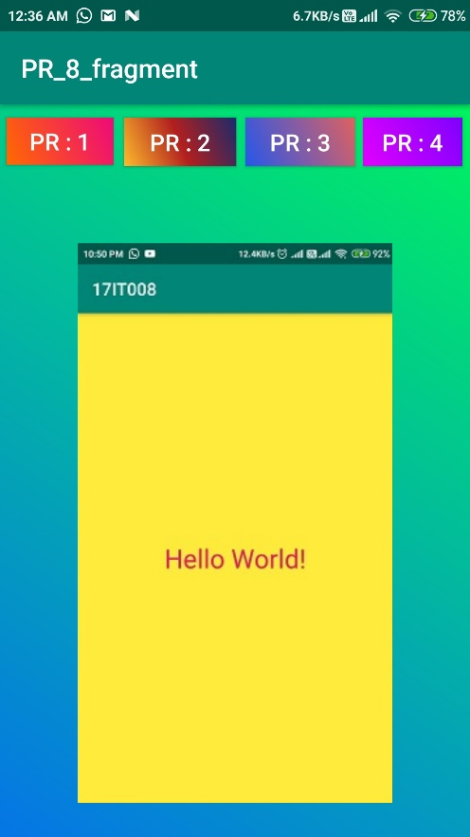**OUTPUT:**

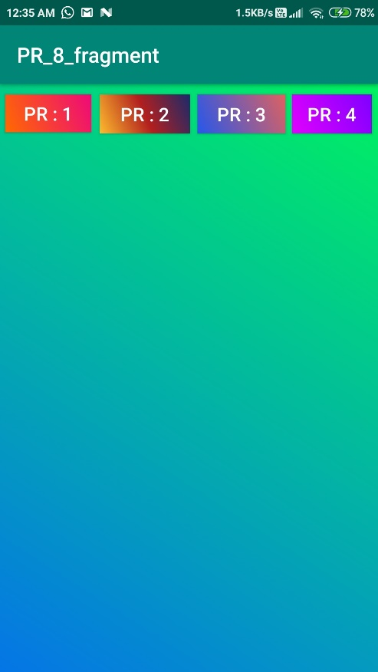

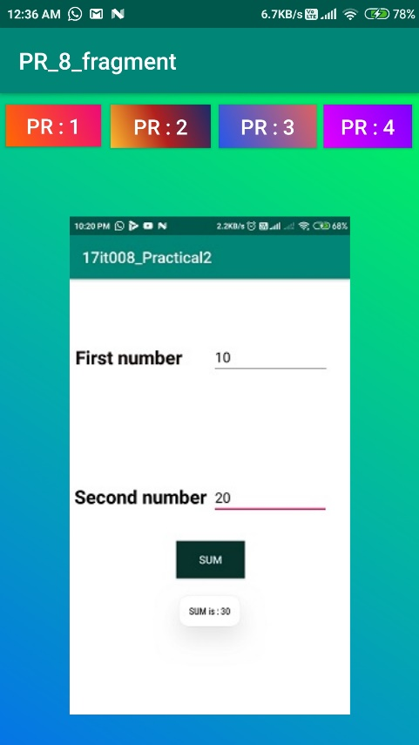

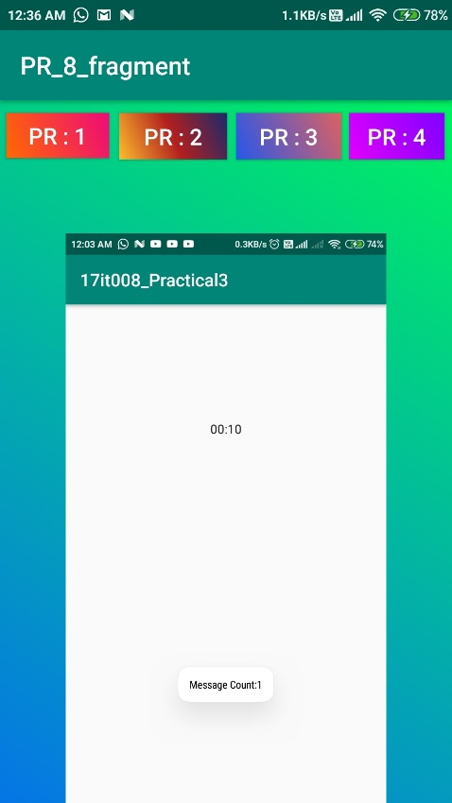

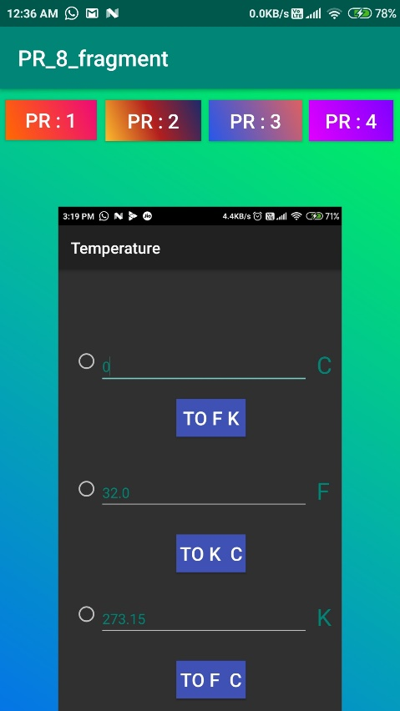

**Description**:

First Screenshot shows the main activity of app and rest of ss shows the fragments view.

**APPLICATIONS:**

Android Studio, ADB (Android Debug Bridge), AVD Manager, Eclipse, Fabric, Genymotion,

**LEARNING OUTCOME:**

1.We learn how to use Fragment in app.